Name Quang Huynh A2H – Review Assignment

**Directions** 🡪 The following is a review of the first 5+ units we did this year. It is meant as a self-check so you can see your progress and what you need to work on. It should take you about an hour, although it is not timed. You may use your notes, scrap paper, and a calculator while doing this. Please attempt this **ON YOUR OWN**, as you are ultimately responsible for what you know, no one else! Place the letter of your choice in the blank provided. Show work as needed.



1) ______ What is the inverse of the following function: ?



a) b)



c) d)



2) ______ If the discriminant of an equation is 10, then the roots are…

a) real, rational, and unequal b) imaginary



c) real, irrational, and unequal d) real, rational, and equal



3) ______ Given: Set *A* = {(1,2), (2,3), (3, 4), (4,5)}. If the inverse of the set is *A*-1, which statement is true?

a) *A* and *A*-1 are both functions b) *A* is a function and *A*-1 is not a function



c) *A* and *A*-1 are not functions d) *A* is not a function and *A*-1 is a function



4) ______ When the function: $f\left(x\right)=x^{2}$ is multiplied by the value of a, where a > 1, the graph of the new function, $g\left(x\right)=ax^{2}$…



a) opens downward and is narrower b) opens upward and is narrower

c) opens downward and is wider d) opens upward and is wider



5) ______ Stanley throws a ball up into the air. The height of the ball above the ground, in feet, is modeled by the function: $h\left(t\right)=-16t^{2}+24t$, where ***t*** represents the time, in seconds, since the ball was thrown. What is the appropriate domain for this situation?



a) b)



c) d)



6) ______ The function: $f\left(x\right)=\frac{x-3}{x^{2}+2x-8}$ is undefined when x equals…



a) 2 only b) 4 or -2



c) 3 only d) 2 or -4



7) ______ The expression: is equivalent to…



a) b)



c) d)



8) ______ Which ordered pair is a solution of the system of equations shown below?



$x+y=5$ ${(x+3)}^{2}+{(y-3)}^{2}=53$

a) (-4, 9) b) (2, 3)



c) (-5, 10) d) (5, 0)



9) ______ Which of the following is equivalent to: ?



a) b)



c) d)

10) ______ Which value is ***not*** contained in the solution of the system shown below?



*a* + 5*b* – *c* = -20

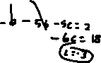

4*a* – 5*b* + 4*c* = 19



–*a* – 5*b* – 5*c* = 2



a) -3 b) 2 c) 3 d) -2



11) ______ Which of the following is equivalent to: ?



a) b)



c) 3 d)

12) ______ The expression: is equivalent to…



a) b) c) d)



13) An error was made when simplifying: $4\sqrt{-12}+3\sqrt{-27}$ below. To the right, explain what errors were made and state the correct solution.



14) ______ Which of the following is the solution set of the equation: $\sqrt{3x+1}+1=x$?



a) {0, 5} b) {5} c) {0} d) { }



15) ______ The expression: $6xi^{3}(-4xi+5)$ is equal to…



a) b)



c) d)



16) ______ Which of the following functions is considered ***even***?



a) b) c) d)



17) ______ To solve: $\frac{2x}{x-2}-\frac{11}{x}=\frac{8}{x^{2}-2x}$, Kodi multiplied both sides first by the least common denominator.



Which statement is true?

a) $\frac{7}{2}$ is an extraneous solution b) 0 and 2 are extraneous solutions



c) This equation does not contain extraneous solutions d) 2 is an extraneous solution

18) ______ Given the following piecewise function: $g\left(x\right)=\left\{\begin{aligned}\frac{1}{2}x+6 \\ 4x+1\end{aligned}\right.$



Find the average rate of change over the interval: $-2≤x≤1$.

a) $\frac{1}{2}$ b) -3 c) 4 d) 9



19) ______ Given: . Find .



a) 4 b) 9 c) 5 d) 0



20) ______ Which relation is one-to-one?



a) b) c) d)



21) ______ Factor completely:

a) b)

c) d)



22) _______ Find the roots of the following equation:



a) b) c) d)



23) ______ The expression: is equivalent to… a) b) c) d)



24) Explain what Shawna did wrong when she simplified the expression below.



$\frac{24-18x}{9x^{2}-16}÷\frac{2x^{2}+2x}{3x^{2}+7x+4}=\frac{6(4-3x)}{(3x+4)(3x-4)}×\frac{(3x+4)(x+1)}{2x(x+1)}=\frac{3}{x}$

Shawna forgot to put a negative sign on the final answer. There was a binomial that when you cancel it out, you have to put a negative on the other side.

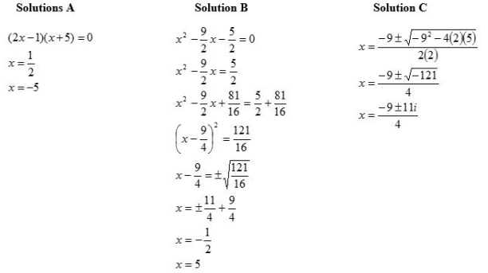25) Three solutions to: $2x^{2}-9x-5=0$ are shown below. Only one of the solutions is correct. Identify which solution is correct and justify your choice.

